# Data cleaning

## Duration reproduction outlier screening

* Lower limit for outlying trial defined as < 1/3 of a second (representing probable accidental button-press)
* Trials below criterion coded as missing

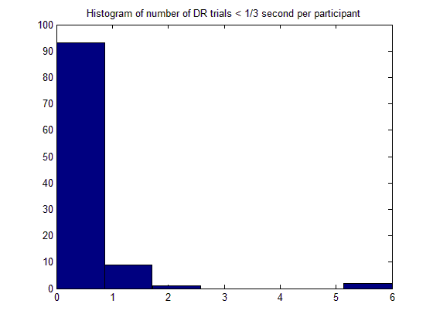

* Upper limit for outlying trial defined as > 3SDs above mean of participant’s relative difference in response (i.e. $\frac{response-interval}{interval}$) for remaining trials
  + Pooled over all 30 trials (5 trials for single interval probably not enough for good estimate of mean and SD, and when pooled, the trials look fairly normally distributed)

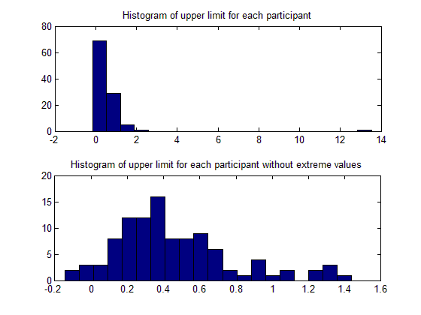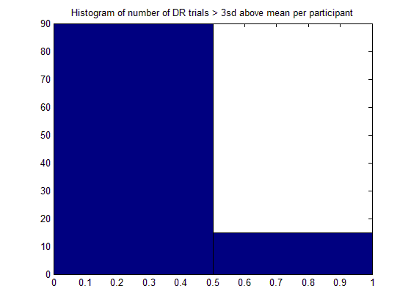

* Trials above criterion coded as missing

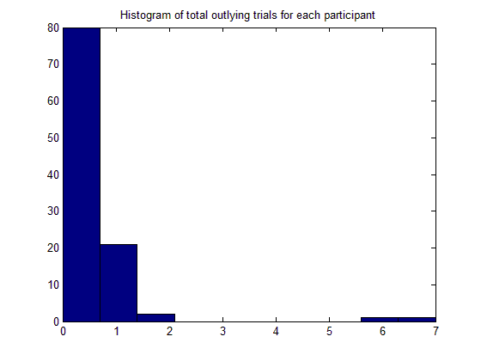

* Average scores for DR task recomputed without outlying trials
  + 25 participants had outlying trials, therefore scores changed for 25 participants

## Temporal discounting task catch trials

* Screening for trials in TD1 where participants presented with options where now option is less than delayed option (in which case it only makes sense to choose the delayed option)
* Summary of catch trials below:
  + Plot contains
    - No. trials
    - No. catch trials
    - No. failed catch trials
    - Vertical dotted lines for two instances of Shuttle problems
  + Ordered on X-axis according to participant number

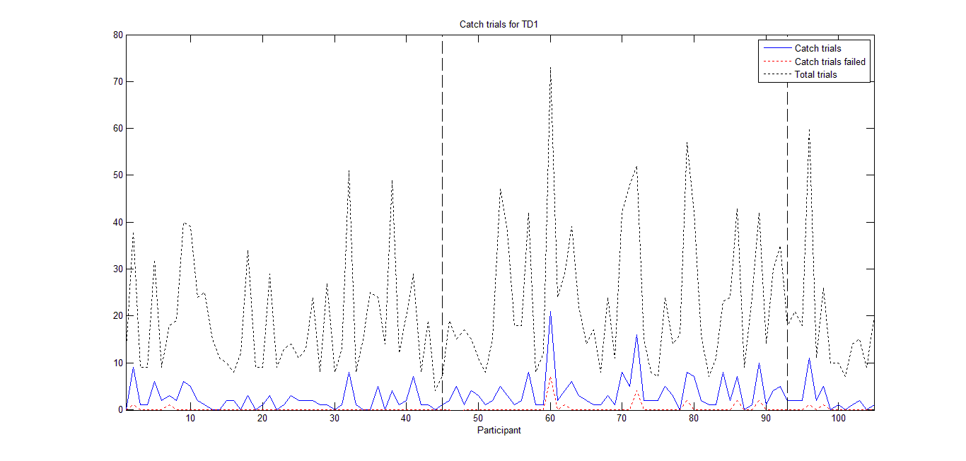

* Excluded participants who failed more than one catch trial (n = 5; excluded only for analyses involving TD task, unless also excluded for other reasons)

## Summary of exclusions (see exclusion filters syntax file for details)

* Participant excluded from analyses of condition effects due to technical issues (e.g. MATLAB crashes before feedback presented) or participants expressing doubt about feedback
  + Participants seem most likely to doubt verbal feedback condition

| **COND * ex_cond Crosstabulation** | | | | |
| --- | --- | --- | --- | --- |
| Count | | | | |
|  |  | ex_cond | | Total |
|  |  | .00 | 1.00 |
| COND | Above | 17 | 1 | 18 |
| Below (overestimated) | 24 | 3 | 27 |
| Below (underestimated) | 19 | 1 | 20 |
| None | 23 | 0 | 23 |
| Above + praise | 11 | 5 | 16 |
| Total | | 94 | 10 | 104 |

* Participants excluded from analyses of TD due to inconsistent responding (i.e. > 1 failed catch trial; n = 5)
* Participants excluded from DR task if extreme outliers and/or gave extremely inconsistent responses (more than two outlying trials based on criteria detailed above; n = 3)
* No overlap between different exclusions (i.e. no participant met the criteria for more than one aspect of the study)

# Analysis of TD data

* K values non-normally distributed; log transformation helps slightly

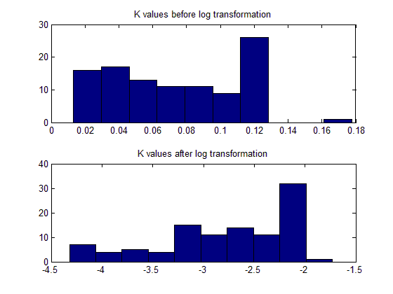

* S values strongly positively skewed; log transformation helps quite a bit

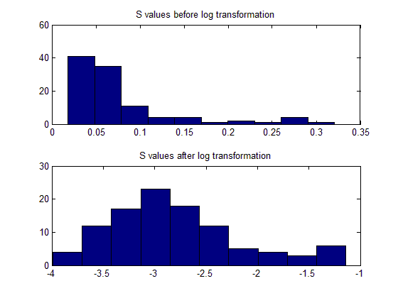

* TD RTs slightly positively skewed; log transformation helps

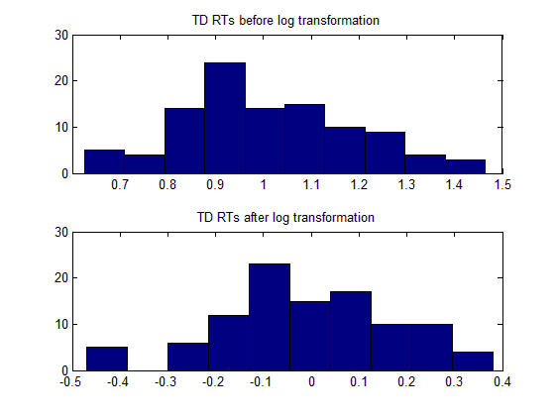

## Correlations with individual difference variables

|  |  |  |  |  |
| --- | --- | --- | --- | --- |
| Spearman correlations (n = 97 to 99) | | | | |
|  | LNTD1 | LNSVAL1 | LNTDRT1 | TD_trials1 |
| LNSVAL1 | **0.380** |  |  |  |
| LNTDRT1 | -0.019 | -0.204 |  |  |
| TD_trials1 | 0.199 | **0.541** | -0.172 |  |
| IPIP Neuroticism | -0.135 | 0.038 | -0.091 | 0.024 |
| IPIP Extraversion | -0.105 | -0.008 | -0.106 | 0.094 |
| IPIP Openness | -0.102 | -0.040 | 0.033 | -0.006 |
| IPIP Agreeableness | -0.042 | 0.020 | -0.122 | -0.009 |
| IPIP Conscientiousness | 0.052 | 0.002 | 0.068 | 0.020 |
| BIS scale | 0.119 | 0.102 | -0.073 | 0.091 |
| BAS drive | -0.073 | -0.201 | -0.035 | -0.043 |
| BAS fun-seeking | 0.098 | -0.044 | 0.073 | -0.045 |
| BAS reward responsiveness | 0.006 | -0.054 | -0.098 | -0.005 |
| BAS global scale | -0.005 | -0.151 | -0.003 | -0.053 |
| Barrat - H/O attentional | -0.031 | 0.010 | 0.091 | -0.018 |
| Barrat - L/O attention | -0.048 | -0.081 | 0.072 | -0.075 |
| Barrat - L/O cognitive instability | -0.031 | 0.131 | 0.061 | 0.095 |
| Barrat - H/O motor | -0.004 | -0.062 | -0.037 | 0.041 |
| Barrat - L/O motor | -0.098 | -0.066 | -0.047 | 0.046 |
| Barrat - L/O perseverance | 0.087 | -0.041 | 0.025 | 0.032 |
| Barrat - H/O non-planning | 0.105 | -0.152 | -0.012 | -0.090 |
| Barrat - L/O self-control | -0.090 | -0.220 | -0.042 | -0.060 |
| Barrat - L/O cognitive complexity | **0.358** | 0.047 | 0.008 | -0.032 |
| Gift 2 m... | **0.533** | 0.169 | -0.068 | -0.071 |
| Gift 4 m... | **0.551** | 0.222 | -0.052 | -0.061 |
| Gift 8 m... | **0.542** | 0.240 | -0.030 | -0.075 |
| Gift 15... | **0.484** | **0.276** | 0.008 | -0.083 |
| Imagine a day 2 months in the future. | 0.097 | -0.010 | -0.129 | 0.018 |
| Imagine a day 4 months in the future. | 0.120 | 0.050 | -0.113 | 0.008 |
| Imagine a day 8 months in the future. | 0.134 | 0.062 | -0.159 | -0.025 |
| Imagine a day 15 months in the future. | 0.215 | 0.152 | -0.073 | -0.017 |
| zaub_auc | 0.009 | 0.125 | 0.025 | 0.071 |

*p* > .05; *p* < .05; ***p* < .01**; ***p* < .001**

# Analysis of DR data

|  |  |  |  |  |  |  |  |  |
| --- | --- | --- | --- | --- | --- | --- | --- | --- |
| Spearman correlations (n = 101) | | | | | | | | |
|  | ABSDR | RELDR | RELDR1 | RELDR2 | RELDR3 | RELDR4 | RELDR5 | RELDR6 |
| IPIP Neuroticism | 0.147 | -0.102 | -0.091 | -0.096 | -0.102 | -0.098 | -0.128 | -0.016 |
| IPIP Extraversion | -0.013 | -0.030 | -0.076 | -0.031 | -0.062 | 0.081 | 0.041 | 0.093 |
| IPIP Openness | -0.050 | 0.053 | -0.034 | 0.003 | 0.147 | 0.084 | 0.079 | 0.054 |
| IPIP Agreeableness | 0.078 | -0.070 | -0.038 | -0.083 | -0.071 | -0.093 | -0.028 | -0.060 |
| IPIP Conscientiousness | 0.051 | 0.012 | 0.012 | 0.088 | -0.041 | 0.030 | 0.042 | -0.084 |
| BIS scale | -0.194 | 0.086 | 0.130 | 0.108 | 0.060 | 0.075 | 0.103 | 0.078 |
| BAS drive | -0.002 | -0.014 | -0.032 | 0.049 | -0.032 | -0.020 | -0.056 | 0.042 |
| BAS fun-seeking | -0.024 | 0.036 | 0.013 | 0.150 | -0.003 | -0.030 | -0.021 | 0.010 |
| BAS reward responsiveness | -0.131 | 0.130 | 0.107 | 0.149 | 0.050 | 0.110 | 0.063 | 0.115 |
| BAS global scale | -0.097 | 0.075 | 0.042 | 0.145 | 0.000 | 0.040 | 0.016 | 0.112 |
| Barrat - H/O attentional | 0.039 | -0.065 | 0.002 | -0.107 | -0.050 | -0.081 | -0.076 | 0.006 |
| Barrat - L/O attention | 0.014 | -0.010 | 0.020 | -0.008 | 0.003 | 0.001 | -0.010 | -0.007 |
| Barrat - L/O cog. instability | -0.065 | 0.063 | 0.033 | 0.029 | 0.069 | 0.039 | 0.010 | 0.072 |
| Barrat - H/O motor | 0.089 | -0.135 | -0.076 | -0.152 | -0.103 | -0.155 | -0.104 | -0.058 |
| Barrat - L/O motor | -0.012 | 0.033 | 0.075 | -0.008 | 0.038 | 0.068 | -0.028 | 0.028 |
| Barrat - L/O perseverance | 0.072 | -0.028 | 0.010 | -0.020 | -0.003 | -0.021 | -0.060 | -0.041 |
| Barrat - H/O non-planning | -0.094 | 0.016 | 0.011 | 0.023 | 0.017 | 0.049 | 0.054 | 0.020 |
| Barrat - L/O self-control | -0.059 | 0.064 | 0.012 | 0.049 | 0.073 | 0.044 | 0.021 | 0.102 |
| Barrat - L/O cog. complexity | -0.074 | 0.061 | 0.066 | 0.033 | 0.071 | 0.047 | 0.021 | 0.014 |
| Gift 2 m... | -0.051 | 0.122 | 0.179 | 0.144 | 0.084 | 0.053 | -0.008 | -0.058 |
| Gift 4 m... | -0.077 | 0.150 | 0.171 | 0.179 | 0.113 | 0.103 | 0.018 | -0.028 |
| Gift 8 m... | -0.061 | 0.106 | 0.134 | 0.154 | 0.068 | 0.097 | -0.002 | -0.078 |
| Gift 15... | -0.061 | 0.074 | 0.089 | 0.121 | 0.026 | 0.114 | 0.032 | -0.069 |
| Imagine 2 months | -0.102 | -0.013 | -0.061 | -0.126 | 0.070 | 0.068 | 0.073 | 0.107 |
| Imagine 4 months | -0.082 | -0.021 | -0.069 | -0.118 | 0.034 | 0.072 | 0.077 | 0.085 |
| Imagine 8 months | -0.005 | -0.090 | -0.052 | -0.154 | -0.061 | -0.023 | -0.018 | 0.037 |
| Imagine 15 months | -0.060 | -0.063 | -0.041 | -0.093 | -0.073 | -0.039 | 0.000 | 0.031 |
| zaub_auc | 0.135 | -0.079 | 0.000 | 0.051 | -0.149 | -0.104 | -0.148 | -0.121 |

*p* > .10; *p* < .10

|  |  |  |  |  |  |  |  |  |
| --- | --- | --- | --- | --- | --- | --- | --- | --- |
| Spearman correlations (n = 101) | | | | | | | | |
|  |  | ABSDR | RELDR | RELDR1 | RELDR2 | RELDR3 | RELDR4 | RELDR5 |
| RELDR | rs | -0.729 |  |  |  |  |  |  |
|  | p | 0.000 |  |  |  |  |  |  |
| RELDR1 | rs | -0.381 | 0.779 |  |  |  |  |  |
|  | p | 0.000 | 0.000 |  |  |  |  |  |
| RELDR2 | rs | -0.481 | 0.849 | 0.716 |  |  |  |  |
|  | p | 0.000 | 0.000 | 0.000 |  |  |  |  |
| RELDR3 | rs | -0.446 | 0.802 | 0.621 | 0.700 |  |  |  |
|  | p | 0.000 | 0.000 | 0.000 | 0.000 |  |  |  |
| RELDR4 | rs | -0.644 | 0.859 | 0.609 | 0.694 | 0.718 |  |  |
|  | p | 0.000 | 0.000 | 0.000 | 0.000 | 0.000 |  |  |
| RELDR5 | rs | -0.811 | 0.723 | 0.333 | 0.467 | 0.437 | 0.624 |  |
|  | p | 0.000 | 0.000 | 0.001 | 0.000 | 0.000 | 0.000 |  |
| RELDR6 | rs | -0.830 | 0.599 | 0.233 | 0.329 | 0.320 | 0.510 | 0.740 |
|  | p | 0.000 | 0.000 | 0.019 | 0.001 | 0.001 | 0.000 | 0.000 |

# TD and DR correlations

|  |  |  |  |  |
| --- | --- | --- | --- | --- |
| Spearman correlations (n = 94 to 96) | | | | |
|  |  | LNTD1 | LNSVAL1 | LNTDRT1 |
| ABSDR | rs | -0.14 | -0.14 | 0.038 |
|  | p | 0.175 | 0.174 | 0.717 |
| RELDR | rs | 0.172 | 0.088 | 0.063 |
|  | p | 0.094 | 0.392 | 0.547 |
| RELDR1 | rs | 0.185 | 0.109 | 0.055 |
|  | p | 0.072 | 0.290 | 0.597 |
| RELDR2 | rs | 0.108 | 0.017 | 0.017 |
|  | p | 0.295 | 0.868 | 0.869 |
| RELDR3 | rs | 0.201 | 0.124 | 0.038 |
|  | p | 0.050 | 0.227 | 0.715 |
| RELDR4 | rs | 0.061 | 0.105 | 0.027 |
|  | p | 0.554 | 0.308 | 0.796 |
| RELDR5 | rs | 0.047 | 0.049 | 0.027 |
|  | p | 0.648 | 0.634 | 0.796 |
| RELDR6 | rs | 0.060 | 0.106 | -0.004 |
|  | p | 0.562 | 0.304 | 0.971 |

9

# Analysis of condition effects on TD2

* Between subjects ANOVA - no significant effect of condition on TD2
* Repeated measures ANOVA - same

| **Descriptive Statistics** | | | |
| --- | --- | --- | --- |
| Dependent Variable:LNTD2 | | | |
| COND | Mean | Std. Deviation | N |
| Above | -2.8099 | .68114 | 16 |
| Below (overestimated) | -2.8435 | .62119 | 22 |
| Below (underestimated) | -2.6483 | .64550 | 18 |
| None | -2.8579 | .59862 | 20 |
| Above + praise | -2.9075 | .72213 | 10 |
| Total | -2.8072 | .63508 | 86 |

| **Tests of Between-Subjects Effects** | | | | | | |
| --- | --- | --- | --- | --- | --- | --- |
| Dependent Variable:LNTD2 | | | | | | |
| Source | Type III Sum of Squares | df | Mean Square | F | Sig. | Partial Eta Squared |
| Corrected Model | .635a | 4 | .159 | .382 | .821 | .019 |
| Intercept | 631.182 | 1 | 631.182 | 1519.430 | .000 | .949 |
| COND | .635 | 4 | .159 | .382 | .821 | .019 |
| Error | 33.648 | 81 | .415 |  |  |  |
| Total | 711.983 | 86 |  |  |  |  |
| Corrected Total | 34.283 | 85 |  |  |  |  |
| a. R Squared = .019 (Adjusted R Squared = -.030) | | | | | | |

